Developing With LQnode

Developing your sensor or actuator project with LQnode is a straightforward effort involving both creation of a “sensor” circuit and adding your C source code driver. Both efforts are supported by templates to facilitate a solid start and rapid completion.

Hardware Circuit

PCB Design Software
LQnode includes hardware templates and source materials to help you rapidly build your project. LooUQ provides these design resources (schematics and PC boards) in two formats: DipTrace and Eagle.
LooUQ uses DipTrace as our primary circuit CAD application. We selected it several years ago and have been pleased with its reasonable cost and solid features. DipTrace is available

Part of most LQnode projects is a custom circuit board (PCB) that is home to the electronics that make your sensor project unique; this could be actual sensors or more likely interface(s) to an external device or system. Beyond the interface itself, your hardware could also include specialized processing capabilities such as high-end computation power, extra memory, or a field programmable gate array (FPGA). This allows your project to utilize the LQnode platform for power and communications, while you focus on your core expertise to address a real-world need.
Start your hardware development with the LQnode-ANNEX PCB template. The template is available as a DipTrace or Eagle format board (https://github.com/LooUQ/LQnode-HW). The template has a board outline, connectors to the LQnode system board, and a placeholder group of prototyping pads. The prototyping connections can be kept or deleted as you see fit.
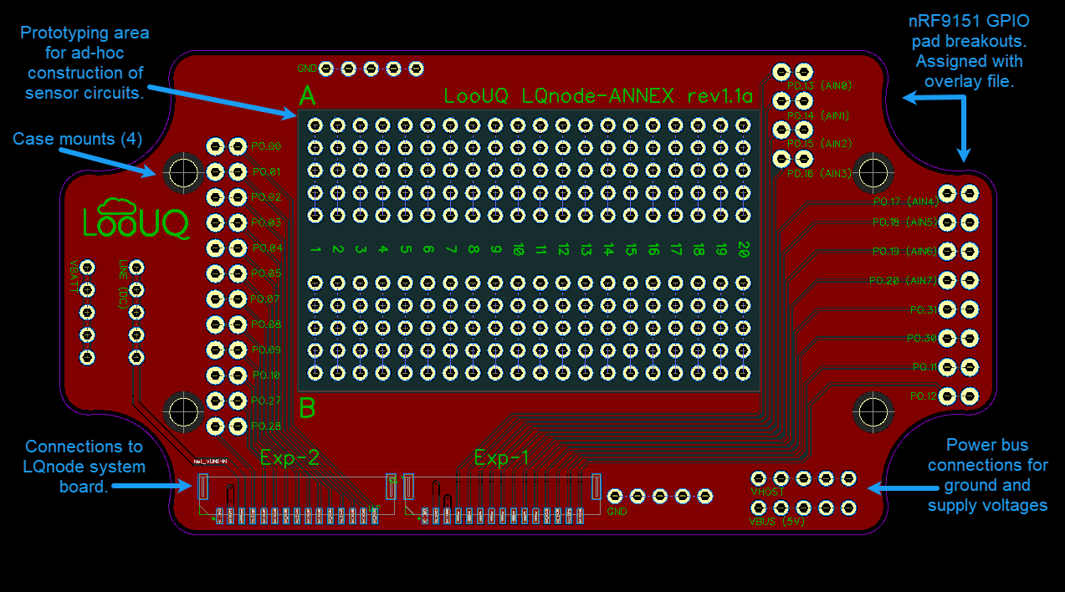
The only part on the prototype template PCB that is required are the two connectors to the LQnode system board. These are common JST BM15B-GHS-TBT(LF)(SN) connectors, you will also find compatible cables and plugs available from multiple sources. This connector has a latch mechanism to lock the connection cable in place.
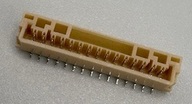

Software Driver
As with hardware development, the best starting point is the LooUQ provided LQnode application template. LQnode software support files including demo applications/ templates and overlays, Zephyr port mappings for Nordic Connect SDK, are available in the https://github.com/LooUQ/LQnode-SW GitHub repository.

Licensing
LooUQ has expended time and money developing the LQnode system for rapid development of IoT device applications. We want its capabilities to be put to work addressing real world needs both for good of all and for profit.
All LQnode components, hardware and software, are available under the Polyform Noncommercial license for non-commercial projects. Polyform Noncommercial is a source-available license, rather than an open-source license. The full source code and component drawings are available for your use, under the license conditions.
Individuals, academic institutions, and non-profit organizations are encouraged to freely use the LQnode system for your project.
Commercial use of LQnode requires a commercial use license that can be obtained from LooUQ. To inquire about pricing and availability of a license compatible with your project please reach out, we are eager to work with you to provide reasonable terms. Licensing inquiries can be directed to answers@loouq.com, we will respond as soon as possible to start working on ways we can work together for mutual benefit.

